PES University – Dept. of CSE
Lab 1: Requirements Engineering & UML Use-Case Modelling
Problem Statement #11 – Healthcare & Telemedicine
Title: Telemedicine Slot Booking & Prescription Portal
Name: _______________________ SRN: _______________________
Section: _______ Date: 31 August 2026

1. Problem Context & Overview
The Telemedicine Slot Booking & Prescription Portal is a secure healthcare consultation platform that allows remote patients to view doctor specialties, book video consultation slots, receive encrypted tele-consultation room links, and download digitally signed prescriptions. The system involves two primary stakeholders: the Patient, who books consultations and retrieves prescriptions, and the Attending Physician, who manages availability, conducts consultations, and authors signed prescriptions.

2. Functional Requirements
ID | Description | Priority | Acceptance Criteria | Rationale
FR-001 | The system shall enable physicians to author and digitally sign structured prescriptions that are automatically compiled into downloadable PDF records. | High | Pass: Valid cryptographic signature attached to prescription PDF.  Fail: Prescription generated without doctor license validation. | Ensures prescriptions are legally valid, tamper-evident, and traceable to a verified physician.
FR-002 | The system shall allow patients to search and filter doctors by specialty, language, and available time slots. | High | Pass: Search returns only doctors matching the selected specialty and showing real-time availability.  Fail: Results include doctors with no published availability or wrong specialty. | Patients need an efficient way to locate a suitable doctor before they can book a consultation.
FR-003 | The system shall allow a patient to book an available video consultation slot with a chosen physician, preventing double-booking of the same slot. | High | Pass: Slot is locked and confirmed only if it was still free at the time of booking; a confirmation is generated.  Fail: Two patients are able to book the same slot simultaneously. | Slot integrity is core to the scheduling function; conflicts directly harm patient trust and physician scheduling.
FR-004 | The system shall generate a unique, encrypted, time-bound video consultation room link and deliver it to both the patient and the physician upon booking confirmation. | High | Pass: Link is valid only within the scheduled window and cannot be accessed by unauthorized users.  Fail: Link remains active outside the consultation window or is guessable/reusable. | Protects patient privacy and consultation confidentiality as mandated by healthcare data-protection norms.
FR-005 | The system shall allow patients to view and download their digitally signed prescription as a PDF from their account after the consultation. | Medium | Pass: Downloaded PDF matches the signed prescription record and displays the verified signature.  Fail: PDF is downloadable before physician signing is complete. | Gives patients self-service access to their medical records for pharmacy use and personal reference.

3. Non-Functional Requirements
ID | Type | Description | Priority | Acceptance Criteria | Rationale
NFR-001 | Performance & Security | All video session metadata and patient clinical notes must be encrypted in transit using TLS 1.3 and at rest with AES-256. | High | Pass: Benchmarking tests confirm target latency and security standards under simulated peak load.  Fail: Any data found unencrypted in transit or at rest. | Healthcare data is highly sensitive; encryption is required for regulatory compliance (e.g., HIPAA-equivalent norms) and patient trust.
NFR-002 | Availability & Reliability | The slot booking and video consultation subsystems shall maintain 99.9% uptime, measured monthly, with automatic failover for the video signaling service. | High | Pass: Uptime monitoring logs show ≤ ~43 minutes of downtime per month and failover completes within 30 seconds.  Fail: Unplanned downtime exceeds the monthly budget or failover does not trigger automatically. | Missed or dropped consultations due to downtime can directly delay patient care, so high availability is critical for a healthcare service.

4. List of Use Cases
The table below lists every use case shown in the UML diagram on the following page, along with its primary actor(s) and a brief description of its purpose.
Use Case | Primary Actor(s) | Brief Description
Login / Authenticate | Patient, Attending Physician | Verifies user credentials and grants role-based access to the portal.
View Doctor Specialties | Patient | Allows the patient to browse and filter physicians by specialty and availability.
Book Consultation Slot | Patient | Lets the patient reserve an available video consultation slot with a chosen physician.
Send Booking Notification | Patient, Attending Physician | Delivers the booking confirmation and encrypted video room link to both parties. Always triggered by Book Consultation Slot («include»).
Reschedule / Cancel Booking | Patient | Allows the patient to change or cancel an existing booking. Optionally extends Book Consultation Slot («extend»).
Join Video Consultation | Patient, Attending Physician | Connects both participants to the encrypted video session at the scheduled time.
Request Technical Support | Attending Physician | Provides in-session help if connectivity issues occur. Optionally extends Join Video Consultation («extend»).
Author & Sign Prescription | Attending Physician | Lets the physician create a structured prescription and apply a digital signature to it.
Validate Doctor License | Attending Physician | Confirms the physician's medical license and signature certificate are current. Always triggered by Author & Sign Prescription («include»).
Download Prescription PDF | Patient | Allows the patient to retrieve the signed prescription as a downloadable PDF.

5. UML Use-Case Diagram
The diagram below models the two primary actors (Patient, Attending Physician) and an external actor (Payment Gateway) against the system's use cases. It includes one <<include>> relationship (Book Consultation Slot always includes Send Booking Notification; Author & Sign Prescription always includes Validate Doctor License) and two <<extend>> relationships (Reschedule/Cancel Booking optionally extends Book Consultation Slot; Request Technical Support optionally extends Join Video Consultation).
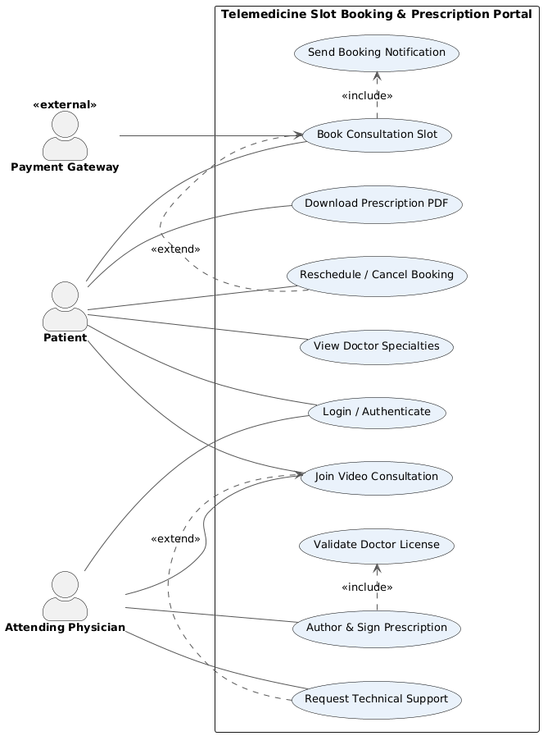

6. Use-Case Flow Specification: Join Video Consultation
Use Case Name | Join Video Consultation
Actors | Patient (primary), Attending Physician (primary)
Preconditions | 1. A consultation slot has been successfully booked and confirmed.  2. The current time is within the scheduled consultation window (or the configured early-join buffer, e.g., 5 minutes before start).  3. Both the patient and physician have received their encrypted video room link.
Postconditions | 1. Both participants are connected in a live, encrypted video session.  2. The system logs session start time, end time, and participants for audit purposes.
Main Success Scenario | 1. Patient clicks the “Join Consultation” link from their booking confirmation or dashboard.  2. System validates that the link is authentic, has not expired, and matches the logged-in patient's identity.  3. System grants access to the encrypted video room and places the patient in a virtual waiting area.  4. Physician joins the same room from their dashboard at the scheduled time.  5. System establishes the encrypted peer connection and notifies the patient that the physician has joined.  6. Patient and physician conduct the consultation via live video/audio.  7. Physician ends the session; system logs the session duration and marks the consultation as “Completed.”
Alternate Flow | A1: Physician Does Not Join Within Grace Period  4a. The physician fails to join within 10 minutes of the scheduled start time.  4a1. System sends an automated reminder notification to the physician.  4a2. If the physician still has not joined after the grace period, system notifies the patient of the delay and offers the option to wait, reschedule, or request a refund.  4a3. If the patient chooses to reschedule, the system invokes the Book Consultation Slot use case with the same physician.

